System Requirement Specification
HKMC LH SBW

Customer: HKMC
Article-Name: LH SBW
Article-Nr. KOSTAL: 10145841/10147903
Document-Nr.: DOC01789464
Version: 0004
State:

 | Responsible: | Signature: | Date:
Created: | Ma Liangyin | Ma Liangyin | 17.08.2016
Int. checked: | Zhou Hu | Zhou Hu | 17.08.2016
Ext. checked:
Release: | Huckfeldt Olaf | Huckfeldt Olaf | 17.08.2016

Distribution: Project team Electronics KOCHI

Table of Contents
1 Table of Contents 2
2 Change History 7
3 Acronyms and Abbreviations 10
4 Scope 11
5 Regulations, Strength and Law 12
5.1 Regulations 12
5.2 Strength 12
5.3 Law 12
6 Environment Requirement 13
6.1 RATED VOLTAGE 13
6.2 OPERATING VOLTAGE RANGE 13
6.3 CONSUMPTION CURRENT 13
6.4 OPERATING / STORAGE TEMPERATURE RANGE 13
7 System Purpose 14
8 System Context 15
9 System Interface 16
10 System overview 17
10.1 Hardware Block Diagram 18
10.2 General Operation 18
10.3 Connector Information 19
11 Common Signal Processing 21
11.1 Ignition Status Input 21
11.1.1 IGN 21
11.1.2 ACC 21
11.2 Door Signal Handling 22
11.2.1 Driver Door (DRV) 22
11.2.2 Assist Door (AST) 23
11.3 Vehicle Speed Signal Handling 23
11.3.1 General 23
11.3.2 VS_TCU Calculation 24
11.3.3 WHL_SPD_FL Calculation 24
11.3.4 Vehicle Driving/Stop Condition 24
11.4 Vehicle Gear position Signal Handling 24
11.5 Switch Handling 24
11.5.1 P switch handling 24
11.5.2 P-Release switch handling 25
11.6 Brake Input Handling 25
11.6.1 Brake Status Judgment 25
11.6.2 Hardwire 25
11.6.3 CF_Lvr_BkeAct for Brake 26
11.6.4 Valid P Switch Press 26
11.6.5 Valid P-Release Switch Press 26
12 Gear Position Request 27
12.1 General 27
12.2 Lever stoke 27
12.3 Lever Operation Force 27
12.4 Lever Pattern 27
12.5 Lever Position Detection 28
12.5.1 HALL sensor judgment 28
12.5.2 Sending Gear Position Pattern Sequence 28
12.6 Unlock Switch Handling 29
12.6.1 CAN signal: “CF_Lvr_UlkButStat” to TCU 29
12.7 Gear Request Logic 29
12.7.1 Optional Function 29
13 Illumination Control 33
13.1 CAN signals 33
13.2 Day Night Judgement 33
13.2.1 Judgment Day/Night mode 33
13.2.2 Timeout Judgement 33
13.2.3 Day Judgement 33
13.2.4 Night Judgement 33
13.3 Backlight Illumination 34
13.3.1 General 34
13.3.2 Operation 34
13.3.3 Diagnosis 35
13.4 Indicator Illumination 35
13.4.1 General 35
13.4.2 Operation 36
13.4.3 Diagnosis 36
14 Communication 36
14.1 CAN Communication 36
14.1.1 CAN Interface 37
14.1.2 CAN Signals 37
14.1.3 CAN Timeout 39
14.1.4 CAN Bus off 39
14.2 PWM Communication 39
14.2.1 PWM Output 39
14.2.2 PWM Input 40
15 PRA Control 41
15.1 PRA Position Detection 42
15.1.1 PRA Sensor 42
15.1.2 T/M Switch 42
15.1.3 PRA Position Determination 43
15.1.4 Error Detection 43
15.2 PRA Motor control 43
15.2.1 PRA Motor control rate 43
15.2.2 Error Detection 44
15.3 PRA Logic 44
15.3.1 IG ON Mode 44
15.3.2 IG OFF Mode 45
15.3.3 Gear N IG OFF Mode 45
15.3.4 N Park Mode 45
15.3.5 Manual Release Function 45
15.3.6 TCU Eol Complete 46
15.3.7 Limp-Home function 46
15.3.8 PRA Disable Voltage 47
16 System Mode Control 47
16.1 General 47
16.2 State Diagram 47
16.2.1 Mode Definition 48
16.2.2 Transition Definition 49
16.3 Sleep Mode (M0) 49
16.4 Door Open Wake up Mode (M1) 49
16.5 IG ON mode (M2) 50
16.6 Gear N IG OFF Mode (M3) 50
16.7 IG OFF Mode (M4) 50
16.8 N Park IG OFF Mode (M5) 50
16.9 Stand-by Mode (M6) 51
17 Power Management 52
17.1 Over/Under Voltage 52
18 Variant Management 53
18.1 General 53
19 UDS Diagnosis 54
19.1 DTC list 54
20 References 55

Change History
Index | Change | Date | Author
0000 | - First Revision copy from DOC01747570-0014 / HKMC_LH_SBW_System_Spec. | 27.07.16 | Ma Liangyin
0001 | - Reviewed with author together, following points are changed directly:  1. change creator from Choi to Ma Liangyin  2. Hardware block diagram in chapter 8.1 updated  3. Change font to Arial for whole content  4. Fill chapter 5, 6, 7  5. Align the pin definition in chapter 8.6 to SR in chapter 8.6 to SR  6. Update the link in chapter 18 for CAN DB, Spec List and Variant List  7. Eliminate the redundant information to CAN DB in chapter 10.1.2  8. Correct the operation temperature in chapter 15.5 to -40deg~85deg  9. Remove the meaningless words “Adding signal” in chapter 16.10.2  10. Fix all the grammatical failures | 28.07.16 | Zhou Hu
0002 | -review with Zhou Hu, Ma Liangyin and Schroeder Andreas together, following points are changed directly:  1. Update system purpose base on ES46700-09E_Function Control Specification Rev. Released.  2. Update system context  3. ACC/IGN: Rename to Ignition Status Input and move to Common Signal Processing.  4. Set up new chapter Environment Requirement and move RATED VOLTAGE, OPERATING VOLTAGE RANGE, CONSUMPTION CURRENT and OPERATING/STORAGE TEMPERATURE RANGE to here as sub chapter.  5. Move Door Signal Handling and Vehicle Speed Signal Handling as sub chapter of Common Signal Processing.  6. Rename Position Detection to Gear Position Request: Lever Position Detection, P Switch Handling, Unlock Switch Handling, P-Release Switch Handling and Gear Request Logic.  7. Rename Illumination to Illumination control.  8. Add Day Night Judgement  9. Rename PRA to PRA Control with these sub functions: PRA Position Detection , PRA Motor Control, PRA Logic  10. Move Error Detection to separate sub chapters.  11. Rename Communication Interface to Communication.  12. Update Block Diagram base on DOC01744276-0003.  13. Add figure and table little titles  14. Change 10.1Block Diagram to Hardware Block Diagram  15. Chapter 6.3, condition and dark current requirement changed. | 02.08.16 | Geng Yuting
0002 | Released | 08.08.16 | Huckfeldt Olaf
0003 | - Move Bake, P switch, P-Release switch chapter to common input processing chapter.  - Create Vehicle Gear position signal handling chapter.  - Add under normal voltage condition in $13.3.2  - Deleted chapter No ACK.  - Change Cf_F_SEL_DESP to G_SEL_DISP.  - Add partial network information.  - Add driver and assist door only for mode management chapter.  - Update PWM interface.  - Update description of Level B door close condition. | 17.08.16 | Ma Liangyin
0004 | Reviewed with author together by walkthrough, following findings are fixed:  - The change date for the version 0003 changed from 12.08.16 to 17.08.16  - Author name for 0003 change from MLY to Ma Liangyin | 17.08.16 | Zhou Hu
0004 | Released | 17.08.16 | Huckfeldt Olaf

MajorDefects: 0 MinorDefects: 0

Acronyms and Abbreviations
Acronyms and Abbreviations | Description
BAT | Battery Voltage
CGW | Central Gateway
D | Driver
DTC | Diagnostic Trouble Code
E-shift Lever System | Electronic Shift Lever System
H/W | Hard Wire
HS-CAN | High Speed-Controller Area Network
HW | Hardware
N | Neutral
P | Park
PH | Physical
PRA | Park Release Actuator, change the Control Lever of T/M 'P' ↔ 'Not P'
PRC | Park Release Cable
PRD | Park Release Driver
P-Release | Park Release
R | Rear
RPM | Revolutions Per Minute
SBW | Shift By Wire
SW | Software
T/M | Transmission
TBD | To be defined
TCU | Transmission Control Unit(Also TCM)
VS_TCU | CAN Message of TCU12, velocity information calculated at TCU

Scope
This document describes the function behaviors of the lever type SBW on LH platform. It defines the operation performance under different vehicle mode.
The whole design of LH SBW will be a completely new design (includes SW, HW, etc.).

Regulations, Strength and Law

Regulations
LH SBW must satisfy regulations according to LH SR

Strength
SBW must satisfy HMC/KMC ENGINEERING SPEC.
(All the related ES specs are listed in the customer drawing. If the customer drawing isn’t available, follow the spec list)

Law
LH SBW must satisfy law according to LH SR

Environment Requirement

RATED VOLTAGE
- SBW RATED VOLTATE: B+ = 12V

OPERATING VOLTAGE RANGE
- NORMAL OPERATING VOLTAGE: 9.0V < B+ < 16.0V

CONSUMPTION CURRENT
- Consumption Current on Sleep Mode with Door Closed, CAN Idle: under 0.1 mA
- Consumption Current on Sleep Mode with Door open, CAN Idle: under 2 mA

OPERATING / STORAGE TEMPERATURE RANGE
Guarantee temperature for environmental reliability
- Storage temperatures: -40℃~+85℃
- Operating temperatures: -40℃~+85℃

System Purpose
The purpose of the SBW system is to provide the lever position signal to TCU via CAN communication and PWM communication. Based on the lever position information, the TCU selects Gear Select information and transmits it to SBW through CAN communication and PWM communication back. On the bezel of SBW, the Gear Select information is visually displayed to show gear information to a driver.

This specification is described to correspond with conditions satisfying the following conditions.

- Vehicle models with the E-Shifter that its concept and design are the lever type.
- Vehicle models with a shifter requiring P/not P control for safety functions such as Fail Safe function execution when TCU breakdown or Fail, and convenient functions such as Parking in “N”.
- TM control is achieved with a Park Release Actuator (PRA) and it operates within the control range of the E-Shifter.

System Context
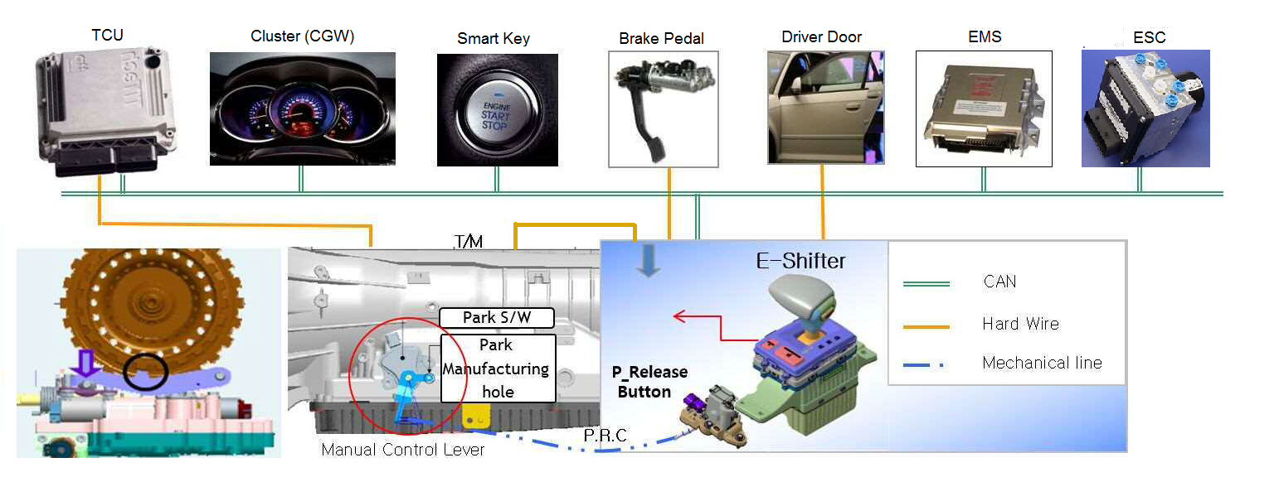
Figure 1: System Context Overview

The E-Shifter is an electronic gear-shifting lever system using a communication link instead of the mechanical link of mechanical gear-shifting lever system. It senses the lever position and controls the manual control lever of T/M in the cases of Engine Off or TCU failure.
After sensing driver’s transmission intention (lever position information), the system transmits it to the TCU as CAN and PWM information, and receives information of each sensor and final gear level from the TCU through CAN and PWM.
The final gear level is displayed on the indicator to provide a driver with gear level information and the T/M manual control switch is controlled as “P” or “Not P” by using the PRA.
When the engine is off, PRA position information is transmitted to a cluster to determine the state between “P” or “N” and received brake information is used for a condition of Parking in N.
When the driver side door or the passenger side door is opened after a certain period of time after parking, the indicator displays “P” or “N” using PRA position information.

System Interface
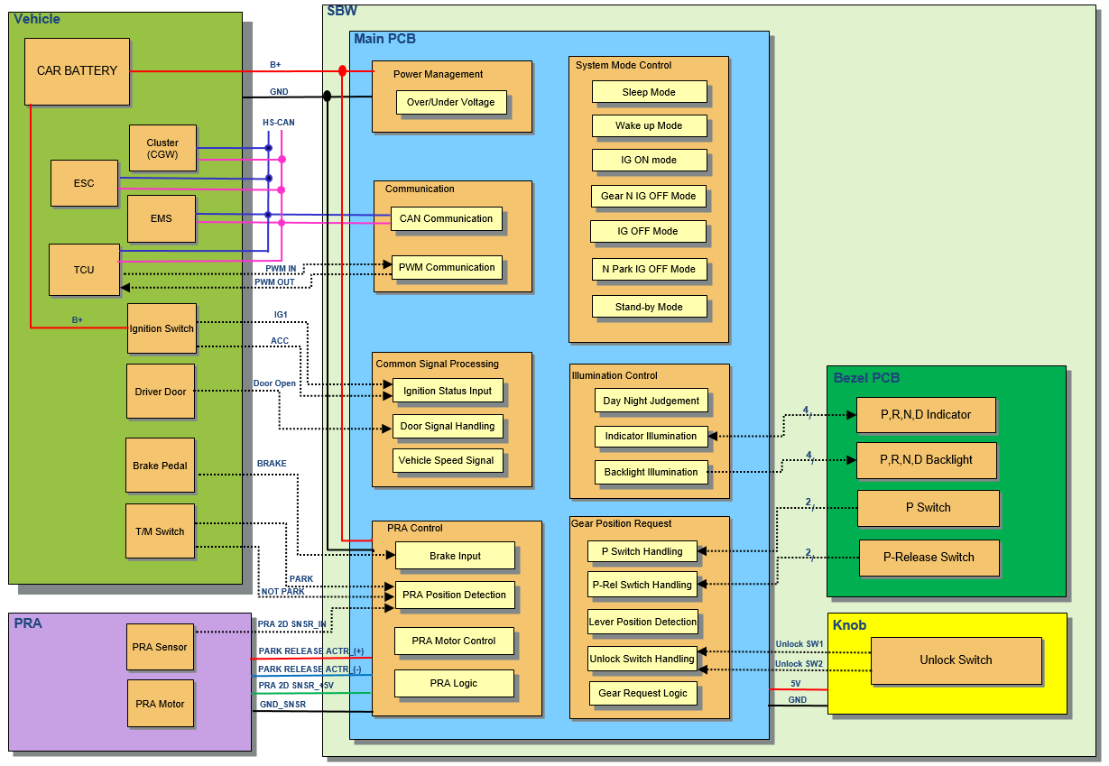
Figure 2: System Interface Overview

SBW consists of a PRA, a Main PCB, a Bezel PCB and a knob. The Main PCB converts driver’s transmission intention (lever position information) into an electrical signal, transmits lever position information to a TCU and processes each sensor information, final gear level information from TCU, vehicle speed and brake signal from a vehicle. The Bezel PCB includes a circuit for P switch, P-Release Switch, indicator illumination and backlight illumination. The unlock switch which comes from knob reflects a driver’s intention and its information will be transmitted by SBW to TCU too.

System overview

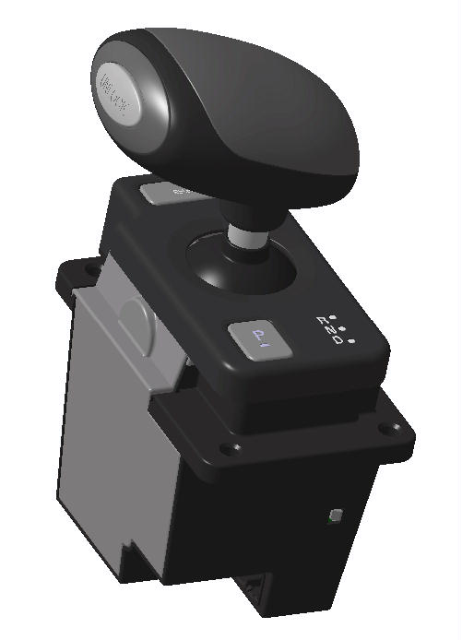

Figure 3: Only concept view

Hardware Block Diagram

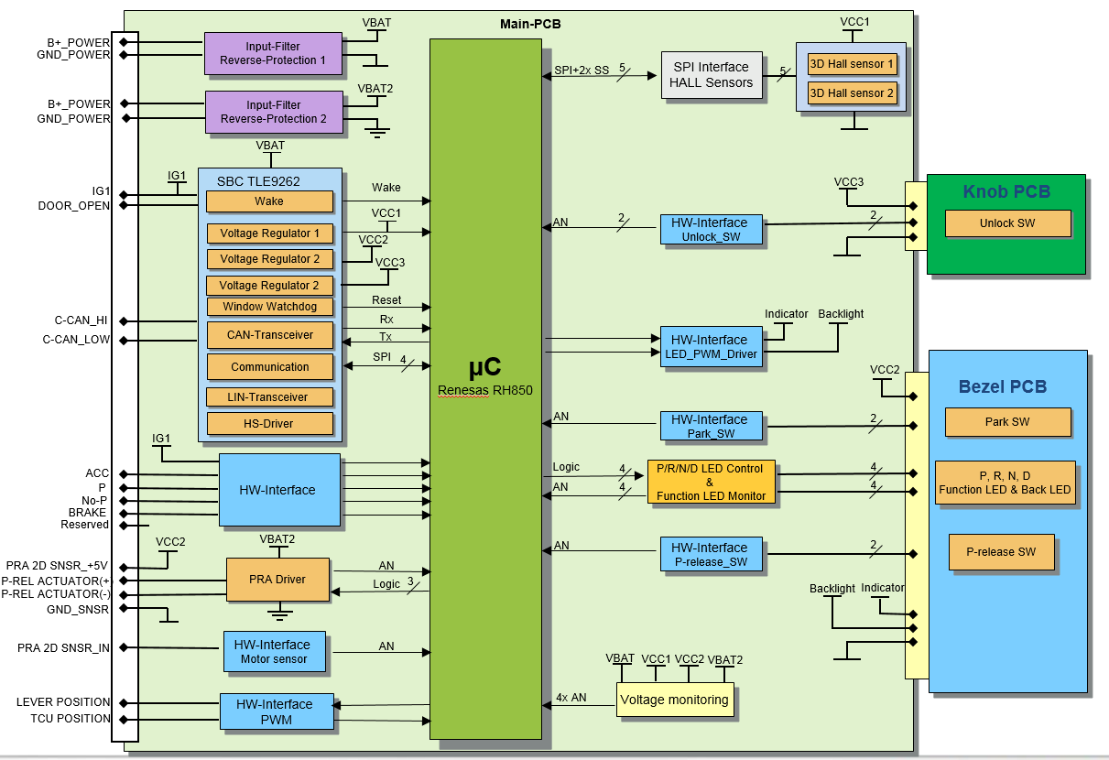
Figure 4: Hardware Block Diagram

General Operation
The SBW receives battery power of vehicle and IG1 On/Off state for SBW control.
SBW tansfers the correspondent lever position to TCU when driver shifts lever. And lever position sensor detects the change of lever position. SBW transfers real time lever positon to TCU through CAN network and Hard-wire(PWM_Out).

The CAN signal of lever position has higher periority than that of Hard-wire(PWM_Out).
TCU determines the gear position based on the lever position signal from SBW and transfers the gear position to SBW through CAN network and Hard-wire(PWM_In).

The CAN signal of gear position has higher periority than that of Hard-wire(PWM_In)
SBW displays gear position on the bezel to make the driver recognize the gear position.

SBW transfers the Unlock Switch status to the TCU through CAN network.

When P switch is activation, SBW shall transfer P position to the TCU through both CAN network and PWM.

P release switch of SBW shall work if and only if SBW is in IGN off mode. And operation is decided by SBW.

Connector Information
- Maker: MOLEX
- Part Name : MULTI LOCK CONNECTOR 20Pin
- Part Number: 68151-2025 (Male), 35564-2015 (Female)
- Sealed: Unsealed
- Pins Part Number: 50654-1001
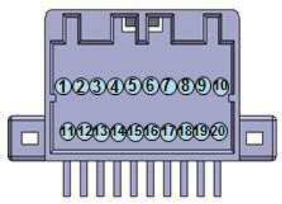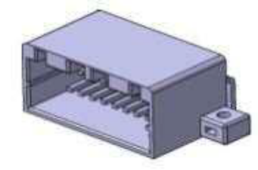
Figure 5: Main connector sectional drawing

NO. | PIN NAME | Description | Remark
1 | B+_POWER | Battery+
2 | PRA 2D SNSR_+5V | PRA Sensor Power
3 | PRA 2D SNSR_IN | PRA Sensor Signal
4 | GND_SNSR | PRA Sensor Ground
5 | C-CAN_LOW | HS-CAN Low Level Signal
6 | C-CAN_HI | HS-CAN High Level Signal
7 | BRAKE | Brake State Signal | ON:B+, OFF:GND
8 | TCU POSITION | TCU Back-up Signal Input PWM | TCU -> SBW
9 | LEVER POSITION | Lever Position Back-up Signal  Output PWM | SBW -> TCU
10 | GND_POWER | Ground
11 | B+_POWER | Battery+
12 | P-REL ACTULATOR(+) | PRA Power
13 | P-REL ACTULATOR(-) | PRA Power
14 | - | No Connect
15 | IG1 | Ignition1 State Input
16 | ACC | Accessory State Input
17 | P | Park State Signal (from T/M) | ON:GND,OFF : Floating
18 | Not-P | Not Park State Signal  (from T/M) | ON:GND,OFF : Floating
19 | DOOR_OPEN | Door Open State Signal | Driver Side
20 | GND_POWER | Ground
Table 1: Pin list

Common Signal Processing

Ignition Status Input

IGN

IGN ON/OFF Judgment
- SBW shall only consider Hard Wire for the IGN ON/Off decision.

Hard Wire Feature

Voltage Level Judgment
- When IGN voltage level is more than or equal to 7V, SBW shall judges IGN as ON.
- When IGN voltage level is less than or equal to 4V, SBW shall judges IGN as OFF.

Hysteresis
- When the IGN voltage level is between 4V and 7V, SBW shall keep the previous status.

Tolerance
- The tolerance could be defined by supplier.

ACC

ACC ON/OFF Judgment
- SBW shall judge ACC ON based on the both hardwire and CAN signal:
- ACC hard wire ON and ACC signal ON, SBW shall judge ACC as ON
- Otherwise, SBW shall judge ACC as OFF.

Hard Wire Feature

Voltage level Judgment
- When ACC voltage level is more than or equal to 7V, SBW shall judges ACC H/W as ON.
- When ACC voltage level is less than or equal to 4V, SBW shall judges ACC H/W as OFF.

Hysteresis
- When the voltage level is between 4V and 7V, SBW shall keep ACC H/W with the previous status.

Tolerance
- The tolerance could be defined by supplier.
- The H/W value should be recognized after 50ms debounce time.

CF_Gway_IGNSw CAN Signal
CAN signal: “CF_Gway_IGNSw” from CGW1:
- Value table:
0x0: Key Off
0x1: Key In
0x2: ACC
0x3: IG
0x4: Start
0x5: Reserved
0x6: Reserved
0x7: CAN Timeout
- CF_Gway_IGNSw is ACC or IG, then SBW shall judge ACC signal as ON, otherwise as OFF.

Door Signal Handling

Driver Door (DRV)

Driver Door Status Judgment
- SBW shall judge driver door Open based on hard wire or CAN signal:
-Driver door hard wire ON || CF_Gway_DrvDrSw == 0x1(Open), SBW shall judge DRV door as open.
-Otherwise, SBW shall judge driver door is closed.

Hardwire Feature

Voltage Level Judgement
- SBW shall judge the DRV Door hard wire as digital. SBW shall have 2 statuses.
- The H/W DRV Door input in Low Active.
- Low Active -> Door Open
- High Not Active -> Door Close

External Circuit
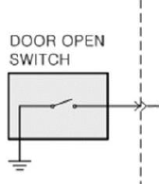
Figure 6: Door open switch block diagram

CF_Gway_DrvDrSw CAN Signal
- CAN signal: “CF_Gway_DrvDrSw” from CGW1:
Value table:
0x0: Closed
0x1: Open
0x2: Reserved
0x3: B-CAN Time-out
If the signal is 0x2 and 0x3, SBW shall consider the Door signal error.

Assist Door (AST)

Assist Door Status Judgment
SBW shall judge only CAN signal for assist door status.
- CF_Gway_AstDrSw == 0x1(Open), SBW shall judge Assist door as open;
- Otherwise, SBW shall judge Assist door as Closed;

CAN Signal
- CAN Signal: “CF_Gway_AstDrSw” from CGW1:
Value table:
0x0: Closed
0x1: Open

Vehicle Speed Signal Handling

General
- SBW shall consider 2 inputs from the CAN network. One is “VS_TCU” CAN signal from TCU and the other is “WHL_SPD_FL” from ESC. “VS_TCU” has higher priority than “WHL_SPD_FL”.
- If the VS_TCU signal occurs timeout or error value, SBW shall consider “WHL_SPD_FL” signal from ESC.
- If both VS_TCU and WHL_SPD_FL are timeout or error value, SBW shall consider keep last valid value.

VS_TCU Calculation
- Signal “VS_TCU” in Message TCU
Conversion: (PH) = 1 * (HEX)
Initial Value: 00H
Error Value: FFH

WHL_SPD_FL Calculation
- Signal “WHL_SPD_FL” in Message ESC
Conversion: (PH) = 0.03125 * (HEX)
Initial value: 0000H
Error value: 3FFFH

Vehicle Driving/Stop Condition
- Vehicle Speed <= 2km/h is considered as Vehicle Stop.
- Vehicle Speed > 2km/h is considered as Vehicle Driving.

Vehicle Gear position Signal Handling
- SBW shall consider 2 inputs from the CAN network ( G_SEL_DISP ) and PWM communication.
- CAN signal (G_SEL_DISP) shall be used as higher priority.
- If the G_SEL_DISP signal is timeout, SBW shall consider PWM from TCU.
- If the G_SEL_DISP signal is fault, SBW shall keep the last valid value.
- If both CAN signal and PWM can’t recognize (not P, R, N, D), SBW shall consider Vehicle Gear position as fault.

Switch Handling

P switch handling
- P Switch should use 2 channels of input. 1-o-o-2 concept should be used. Either one channel is detected ON, P switch should be consider as ON. Otherwise, P switch should be consider as OFF.
- 50ms debounce time should be implemented for each channel input.
- When activated P Position by P switch On, SBW shall send the P position for 100ms. Then send the actual real time lever position again.
If this switch is being ON for over 3 mins, SBW shall consider this switch as stuck and treated as switch OFF. The switch stuck will be recovered after the switch is OFF.

P-Release switch handling
- P-Release Switch should use 2 channels of input. 2-o-o-2 concept should be used. Both channels are detected ON, P-Release switch should be consider as ON. Otherwise, P-Release switch should be consider as OFF.
- 50ms debounce time should be implemented for each channel input.
- If either channel of switch is being ON for over 3 mins, SBW shall consider this switch as stuck and treated as switch OFF. The switch stuck will be recovered after the switch is OFF.

Brake Input Handling
This signal indicates that a driver is pressing the brake pedal or not.

Brake Status Judgment
- SBW shall only consider Hard Wire for the brake ON/Off decision.

Hardwire

Voltage Level
- SBW shall judge the brake input wire as digital.
- Brake ON -- High
- Brake OFF -- Floating

External Circuit
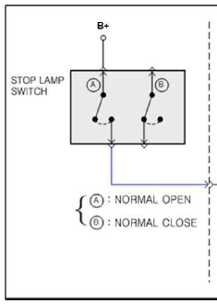
Figure 10: Brake block diagram

CF_Lvr_BkeAct for Brake
When judged the brake input as digital, SBW shall send the “CF_Lvr_BkeAct” on the CAN network to TCU.

CAN signal: “CF_Lvr_BkeAct” to TCU
Value table:
0x0: Brake Pedal OFF
0x1: Brake Pedal ON

Valid P Switch Press
A valid P switch press means the park switch is not earlier pressed than the brake switch ON.
An invalid P switch press means the park switch is earlier pressed than the brake switch ON which will indicate the warning signal according to the DTC list.

Valid P-Release Switch Press
A valid P-Release switch press means the P-Release switch is not earlier pressed than the brake switch ON.
An invalid P-Release switch press means the P-Release switch is earlier pressed than the brake switch ON which will indicate the warning signal according to the DTC list.

Gear Position Request

General

Except P Position, SBW shall keep sending the gear position according to the hall sensor value.

Lever stoke
Lever Positon | STROKE(mm)
Nd -> R | 10.4±1.0
Nd -> Nd | 10.8±1.0
Nd -> Nr | 10.8±1.0
Nd-> D | 10.4±1.0
Table 2: Lever stoke

Lever Operation Force
- Nr→R : 2.05±0.15kgf
- Nd→Nd : 1.4±0.15kgf
- Nd→Nr : 1.5±0.15kgf
- Nd->D : 2.05±0.15kgf

Lever Pattern
- 2 stable – 4 position

Nr
Nd
R
D
“Nr”/”Nd”: Stable
“R”/”D”: Unstable
Figure 7: Lever pattern diagram

Lever Position Detection

HALL sensor judgment
The SBW shall use 2 hall sensor to detect the lever position.
The judgement of the 2 hall sensor should follow below table. In case 2 or 3 or 4, DTC should be set according to the DTC list.
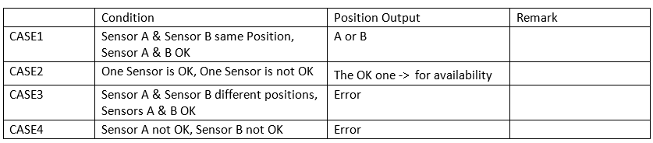
Table 3: Hall sensor judgement cases

Sending Gear Position Pattern Sequence

The SBW shall send the actual real time lever position(R, Nr, Nd, D) via CAN (CF_Lvr_PosInf, CF_Lvr_PosCpl) and PWM.

Unlock Switch Handling
- Unlock Switch should use 2 channels of input. 2-o-o-2 concept should be used. Both channels are detected ON, Unlock switch should be consider as ON. Otherwise, Unlock switch should be consider as OFF.
- 50ms debounce time should be implemented for each channel input.
- When judged the unlock switch, SBW shall send the “CF_Lvr_UlkButStat” on the CAN network to TCU
- If either channel of switch is being ON for over 3 mins, SBW shall consider this switch as stuck and treated as switch OFF. The switch stuck will be recovered after the switch is OFF.

CAN signal: “CF_Lvr_UlkButStat” to TCU
- Value table: 0x0:Not supported/
0x1: Safety Button Off/
0x2: Safety Button On/
0x3: Fault

Gear Request Logic

Optional Function
The control logic contains modules as Gear Change Request Determination, Driver Seat Belt off Module, Door Open Module, Driving Module, Brake off Module, Warning Module.
The following control logics are only available when IGN ON and engine is running.
All the optional function shall be enable/disable by software.

Door Open Auto P Mode

Adding CAN Signal

Name | Closed | Open | Transmitter | Remark
CF_Gway_DrvDrSW | 0 | 1 | CGW | Driver Door Open/Closed status
CF_Gway_AstDrSW | 0 | 1 | CGW | Assistant Door Open/Closed status
CF_Gway_RLDrSW | 0 | 1 | CGW | Rear left Door Open/Closed status
CF_Gway_RRDrSW | 0 | 1 | CGW | Rear right Door Open/Closed status
Table 4: CAN signal list for door open auto P mode

Description
The purpose of this mode is to provide improving the safety
- If either door is open(Level B), vehicle stop, gear D or R and brake on to off, then SBW shall send P signal
- If either door is open (Level A), vehicle stop, gear P or N and detecting position D or R, then SBW shall send warning message (CF_Lvr_ShtErrinf -> bit4)
- If either door is open (Level A), vehicle stop, gear D or R and detecting position P or N, then SBW shall send detecting position to TCU
- If either door is open (Level A), vehicle stop, gear D and detecting position R, then SBW shall send warning message (CF_Lvr_ShtErrinf -> bit4)
- If either door is open (Level A), vehicle stop, gear R and detecting position D, then SBW shall send warning message (CF_Lvr_ShtErrinf -> bit4)

Door Open Status Process
The door status is determined for 2 levels: Level A and Level B.
Level A: the door status is open if any door of Driver Side, Assist Side, Rear Left Side, and Rear Right Side is open. The door status is closed when all doors are closed.
Level B: the door status is open if any door of Assist Side, Rear Left Side, and Rear Right Side is open. The door status is closed when all Assist Side, Rear Left Side, and Rear Right Side are closed

Driver Seat Belt OFF Auto P
Name | Unbelt | Belt | Transmitter | Remark
CF_Gway_DrvSeatBeltSw | 0 | 1 | CGW | Driver seat Belt/Unbelt status
CF_Gway_AstSeatBeltSw | 0 | 1 | CGW | Assistant seat Belt/Unbelt status
Table 5: CAN signal list for driver seat belt off auto P

Description
The purpose of this mode is to provide improving the safety
This function should be operated when all doors are closed. (Level A)
- If driver seat belt is off, vehicle stop, gear D or R and brake on to off, then SBW send P signal.
- If driver seat belt is off, vehicle stop, gear P or N and detecting position D or R, then SBW shall send warning message (CF_Lvr_ShtErrinf -> bit5)
- If driver seat belt is off, vehicle stop, gear D or R and detecting position P or N, then SBW shall send detecting position to TCU
- If driver seat belt is off, vehicle stop, gear D and detecting position R, then SBW shall send warning message (CF_Lvr_ShtErrinf -> bit5)
- If driver seat belt is off, vehicle stop, gear R and detecting position D, then SBW shall send warning message (CF_Lvr_ShtErrinf -> bit5)

Driver Seat Belt Off Status Process
The Driver Seat Belt status contains 2 states: On and Off.
On: driver seat belt is locked by driver.
Off: driver seat belt is unlocked

Auto N Mode
Description
The purpose of this mode is to help a reduction of fuel consumption by memorizing and learning a driver’s habit.

Mode Set Condition
To enter this mode, such below condition should be satisfied to calculate the timing of moving from D to N.
a. While IGN ON, Vehicle stop, Engine Running, D gear, SBW shall record the time that driver move the gear from D to N if the time is less than 10s.
b. In last 3 times of driving cycle (IGN ON -> IGN OFF) and 20 value is recorded.

At this moment, SBW should calculate the recorded time of the 20 times moving, The SBW should calculate the average value of the timing except the MAX and MIN timing value.
After the average timing is set, SBW should keep and use this value all the time unless the Mode be reset.

After Mode Set
- After the mode set, on the condition of Engine Running, Vehicle Stop, Gear=D and Brake On, when the average timing has expired, the SBW shall send Gear N to TCU. After that, when the brake becomes off, The SBW shall send Gear D to TCU.

Mode Reset
- To clear Auto N Mode, keep pressing P Release Switch for 5 sec with the condition of Engine Running, Vehicle Stop, and Brake On, The Auto N Mode should be clear. SBW could set the Auto N mode in another 20 times of driving habit during 3 driving cycles.

Illumination Control

CAN signals
The SBW shall receive CF_GWAY_DetentOut, CF_Clu_RheostatLevel and CF_Gway_LightSwState via CAN for illumination control.

Day Night Judgement

Judgment Day/Night mode
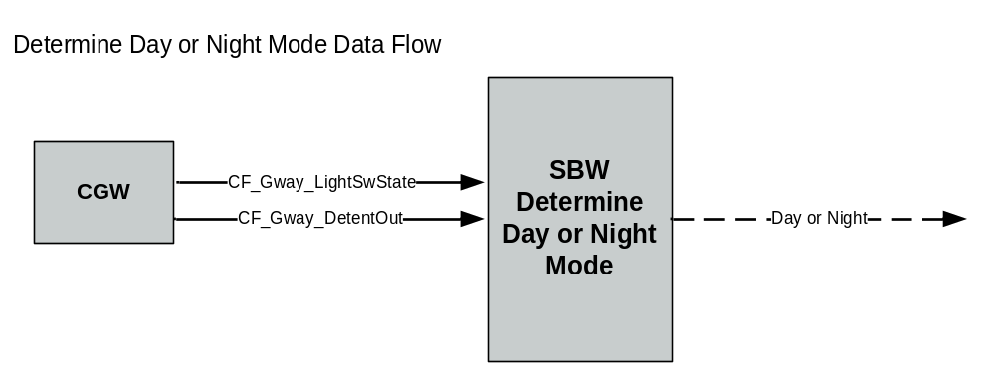
Figure 8: Day or Night Mode data flow

Timeout Judgement
- SBW shall enter the timeout mode, when receiving the CF_Gway_LightSwState or CF_Gway_DetentOut or CF_Gway_RheostatLevel is timeout.

Day Judgement
- SBW shall enter the day mode, When receiving CF_Gway_LightSwState == 0x0(Light Sw Off)&&No CAN timeout
- SBW shall enter the day mode, When receiving CF_Gway_LightSwState == 0x1(Tail Sw On) or 0x2(HeadLamp Low Sw On) or 0x3(AutoLight Sw On) && CF_Gway_DetentOut== 0x1:ON(Daytime Max)&&No CAN timeout

Night Judgement
- SBW shall enter the night mode, When receiving CF_Gway_LightSwState == 0x1(Tail Sw On) or 0x2(HeadLamp Low Sw On) or 0x3(AutoLight Sw On)&& CF_Gway_DetentOut== 0x0:OFF(Night Max)&& No CAN timeout

Backlight Illumination

General

The SBW shall receive the illumination signal from CAN. According to the day/night mode and illumination level, the SBW shall light the backlight LED by PWM.
The SBW contains 4 backlight LEDs for position P, R, N, D
The PWM frequency shall be 488 Hz.
The duty cycle modulation shall be used to control the brightness of LED.

Operation
Except standby and sleep mode, the backlight always turn on under normal voltage.

Timeout mode
SBW shall control PWM duty on 50%.

Day Mode
SBW shall control PWM duty on 100%

Night Mode
SBW shall control to corresponding the Rheostat level as below

Rheostat Step | STEP | Bright
RheostatSWLevel00 | 0(Reserved) | 0 %
RheostatSWLevel01 | 1 | 2.5%
RheostatSWLevel02 | 2 | 2.5%
RheostatSWLevel03 | 3 | 3%
RheostatSWLevel04 | 4 | 4%
RheostatSWLevel05 | 5 | 4.5 %
RheostatSWLevel06 | 6 | 5.5%
RheostatSWLevel07 | 7 | 6.5%
RheostatSWLevel08 | 8 | 8%
RheostatSWLevel9 | 9 | 10%
RheostatSWLevel10 | 10 | 12 %
RheostatSWLevel11 | 11 | 14 %
RheostatSWLevel12 | 12 | 16.5 %
RheostatSWLevel13 | 13 | 16.5%
RheostatSWLevel14 | 14 | 21.5%
RheostatSWLevel15 | 15 | 25.5%
RheostatSWLevel16 | 16 | 29%
RheostatSWLevel17 | 17 | 34 %
RheostatSWLevel18 | 18 | 39%
RheostatSWLevel19 | 19 | 45%
RheostatSWLevel20 | 20 | 50 %
RheostatSWLevel21 | 21 | 100 %
Table 6: Rheostat level list

Diagnosis
There is no diagnosis on backlight illumination

Indicator Illumination

General
The SBW shall receive the illumination signal from CAN. According to the signals, the SBW shall light the LED by PWM.
The PWM frequency shall be 488 Hz.
The duty cycle modulation shall be used to control the brightness of LED.
There are total four indicators on the bezel to show the vehicle gear position:
- P indicator
- R indicator
- N indicator
- D indicator
The indicators should be controlled according to the Vehicle gear position sent by TCU when IG is ON. If the Vehicle gear position is fault, SBW shall turn off all the indicators.
The indicators should be controlled according to PRA position when IG OFF. While PRA is at P position, SBW shall light P indicator. While PRA is at Not P position, SBW shall light N indicator.
All the indicators shall have one channel A/D independently to read back which can diagnose faults.

Operation

General
- After 500ms continuously IGN ON, SBW should display the indicator according to gear information from TCU.
- After 500ms continuously IGN OFF, SBW should display the indicator according to PRA Sensor position.
- Otherwise, SBW should display the indicator according to PRA Sensor position.

Timeout mode
SBW shall control PWM duty on 50%.

Day Mode
SBW shall control PWM duty on 100%

Night Mode
SBW shall control PWM duty on 50%

Blinking Mode
Blinking periodic: 300msec
N Blinking
- In the N Park mode, after 1500ms P switch pressed，if PRA sensor is Not P or error and TM SW is not P status then SBW shall blink the N indicator. While the N indicator is ON, SBW shall set the CF_Lvr_PNStat to 0x2. While the N indicator is OFF, SBW shall set the CF_Lvr_PNStat to 0x3.

Diagnosis
Every indicator LED needs one channel A/D read back, to diagnose short circuit, open circuit.
All the fault diagnosis shall have a 200ms debounce time.
After diagnosed fault, SBW shall send out the “CF_Lvr_GearInf “signal via CAN.
If the LED read back status is not equal to the required display indicator position (TCU gear position or PRA sensor), SBW shall turn the indicator OFF. The failsafe protect shall be recovered after indicator position changed.

Communication

CAN Communication

CAN Interface
The SBW contains one channel 500Kbit HS-CAN.
The HW interface shall be designed like below circuit and the component value shall also been followed:

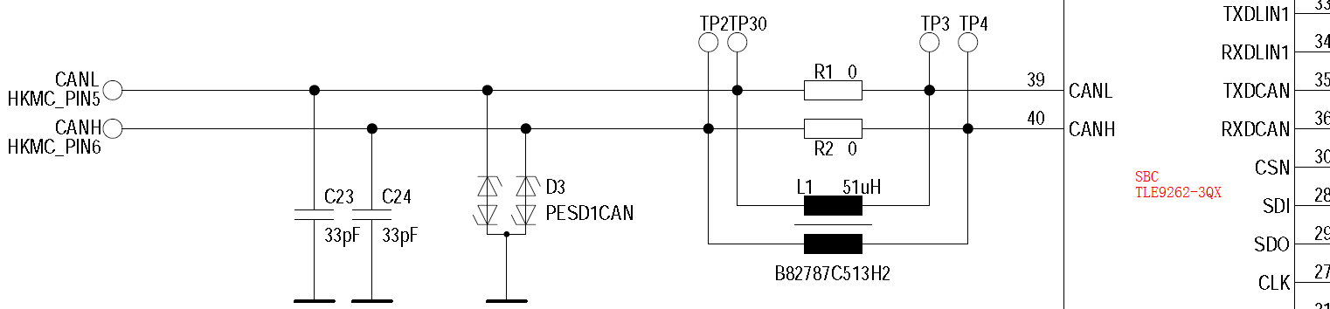
L1 is optional, if we can pass EMC test without L1 then don’t assemble it.

CAN Signals
SBW shall follow the official signal list LH CAN DB. CAN signal layout shall follow the Intel format.

TX Signals
General
The SBW shall send out the current status of detecting lever position on message LVR1 (CF_Lvr_PosInf) and reversed status detecting lever position (CF_Lvr_PosCpl)
The SBW shall also send current indicator status via CAN (CF_Lvr_GearInf)
Alive counter (CF_Lvr_AC) shall be added 1 in every CAN message. The initial value of the counter shall be 0 and the max value is 15. After count to 15, the next value shall be 0.
A checksum (CF_Lvr_CS) shall be used to check the whole message.
The formula shall like this: Checksum=10H-(Least significant nibbles of (Byte0 + Byte1 + Byte2 + Byte3 + Byte4 + Byte5 + Byte6) + Most significant nibbles of (Byte0 + Byte1 + Byte2 + Byte3 + Byte4 + Byte5))

CF_Lvr_NFnStat

- If N Park mode is activated, its value is 01H for 20s.
- If in Gear N IGN OFF mode and Door Open happens, SBW shall set value to 01H for 30s.
- If in IGN ON wake up mode and vehicle stop and door open and gear N, SBW shall set value to 01H for 30s after IGN OFF.
- Otherwise, this signal shall be set to 00H.

CF_Lvr_NWStatus
- If door is open in IGN ON mode and SBW goes to Gear N IGN OFF mode, SBW shall set 01H of value in Gear N IGN OFF mode and IGN OFF mode.
- Otherwise, this signal should be set to 00H.

CF_Lvr_PRelStat
The SBW sends this signal to the TCU so that TCU can acknowledge if the parking device is released by SBW.
Th CLU receives the signal from E-Shifter so that CLU can synchronize between cluster & SBW knob display.
SBW shall detect PRA position and send like below:
Signal Value Table | PRA Position
0x0: Parking Not Released | PRA P Position
0x1: Parking Released | PRA not P Position
Table 7: CF_Lvr_PRelStat value table

If the detected PRA Position is in error or fault, the SBW shall keep the last valid value for the signal CF_Lvr_PRelStat.

CF_Lvr_PNStat
This signal represents status of Park or Not Park.
The CLU receives this signal from E-Shifter so that CLU can synchronize between cluster & SBW knob display.
SBW shall detect PRA position and send like below:
Signal Value Table | PRA Position
0x0: Initial Value | N/A
0x1: Park Status | PRA P Position
0x2: Not Park Status | PRA not Position
0x3: No Display | PRA Position Error or Fault
Table 8: CF_Lvr_PNStat value table

CF_Lvr_ShtLkStat
SBW shall always set this signal as at start value.

CF_Lvr_ShfErrInf
See the DTC List and Waring list document.

CF_Lvr_GearInf
This signal is combined with PRA sensor position value and LED error indicator.
0x0- PRA sensor positon at P
0x5- Reserved
0x6- PRA sensor positon at Not P
0x7- Reserved
0x8- Reserved
0x9- Initial value
0xA- Reserved
0xB- Reserved
0xC- Reserved
0xD- Reserved
0xE- Reserved
0xF- Indicator and PRA sensor fau

Rx signals

For the signal time-out value, DTC related signal shall follow the definition in DTC list and not DTC related signals shall follow the definition in signal list.

G_SEL_DISP/VS_TCU timeout
These signal timeout shall be consider as time out only in IGN ON.

CAN Timeout
- Except special requirement, SBW shall follow defined timeout time in the LH CAN DB

CAN Bus off
The CAN controller uses counters for reception and transmission errors. When the transmission error counter (TEC) exceeds the value of 255, the CAN controller shall go into bus off state.
The CAN bus off recovery time shall be 70ms

- Detail requirements, SBW shall meet the HKMC CAN spec.

PWM Communication

PWM Output

PWM Output Summary
The SBW shall send the lever position to TCU via PWM.
The PWM frequency shall by 100Hz.
PWM is back up communication with TCU and should only be counted when CAN is not properly operating.
PWM On Duty Error: +/- 3%
High: 6V<V<16V
Low: Floating (0V<V<4V)

PWM Output Hardware Interface

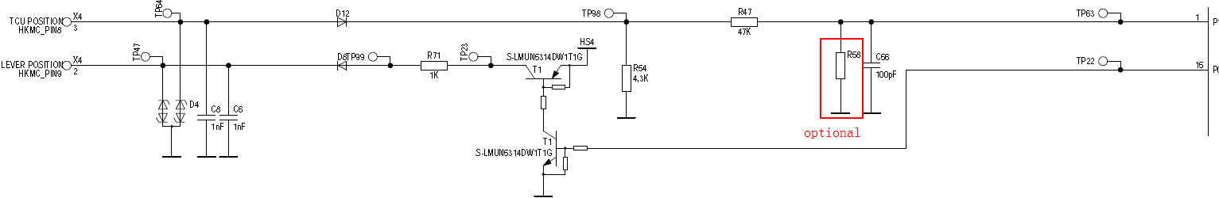
PWM_OUT: There is one 33.2K pull down resistor on TCU side.

PWM Output signals
Gear position Status | PWM On Duty
Fault | 0% or 100%
P | 10%
R | 20%
Nr | 30%
Nd | 40%
D | 50%
Initial | 90%
The duty value defined in above table shall be followed.
The duty cycle shall be changed by different lever position.
SBW should immediately send the P, R, Nr, Nd status when detecting changed lever position.
If SBW can’t detect any lever position. SBW shall send fault status
(CF_Lvr_PosInf is “Fault”), PWM will set to “Fault”.
While SBW in initial mode, PWM could send "Fault" for a period less than 200ms.

PWM Input

PWM Input Summary

The SBW shall receive the gear select information to turn on the indicator from TCU via PWM.
The PWM frequency shall by 100Hz.
PWM is back up communication with TCU and should only be counted when CAN (G_SEL_DISP) is not properly operating.
PWM On Duty Error: +/- 3%
High: 6V<V<16V
Low: Floating (0V<V<4V)

PWM Input Hardware Interface
PWM_IN: TCU side is open drain output. External hard wire using 3.16K pull up resistor connect to BAT+.
.

PWM Input signals
Gear Status | PWM On Duty
Fault | 0 or 100%
P | 10%
R | 20%
N | 30%
D | 40%

SBW shall receive P, R, N, D, and PWM duty cycles from TCU.
SBW shall recognize receiving PWM signal even if one cycle of PWM from TCU.
This PWM signal only use when the “G_SEL_DISP” CAN signal is timeout and IGN is ON.

PRA Control
  - PRA is a structure which includes motor, cable and sensor.
  - PRA Motor is controlled by SBW according to vehicle state.
  - PRA Cable is connected with T/M switch lever. Pull or release the cable can make vehicle to Not Park state or Park state in some case.
  - PRA sensor is used to sense the motor and cable position.
  - SBW controls PRA under the certain conditions which are N Park, N Wash, TCU Timeout, TCU request, PRA manual control, P release switch operation.
  - If the PRA is operating, SBW will not response the new operation request until the operation is finished.
  - SBW shall only operate the PRA actuator only the target position is different from current PRA position.

PRA Position Detection
This part reads PRA sensor and T/M switch value from Transmission side to determine the actual PRA position status in “P“ or “NotP“.

PRA Sensor
This signal is from PRA motor side, and the voltage is described below:
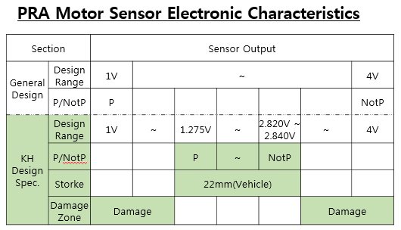
Table 9: PRA motor sensor electronic value table

1.275V—P position
2.82~2.84V—Not P position
Other voltage – Error position
The range of each position must be measured the range on real vehicle then decide the used range of each position.

T/M Switch
- T/M switch is located on Transmission Side, which can be pulled or released by PRA.
- There are two input signals for T/M switch: P signal, Not P signal.
- When TCU is not powered off, TCU will directly control T/M switch. When gear is P, T/M switches are “P position”; when gear is R/N/D/M, T/M switches are “Not P position”.
Otherwise, T/M switches’ position can be changed by operating PRA motors.

T/M Switch Position Detection:
- P signal is Low Level and Not P signal is High level presents T/M switch state is equal to “P position”.
- P signal is High Level and Not P signal is Low level presents T/M switch state is equal to “Not P position”.
- Otherwise T/M switch state is failure.

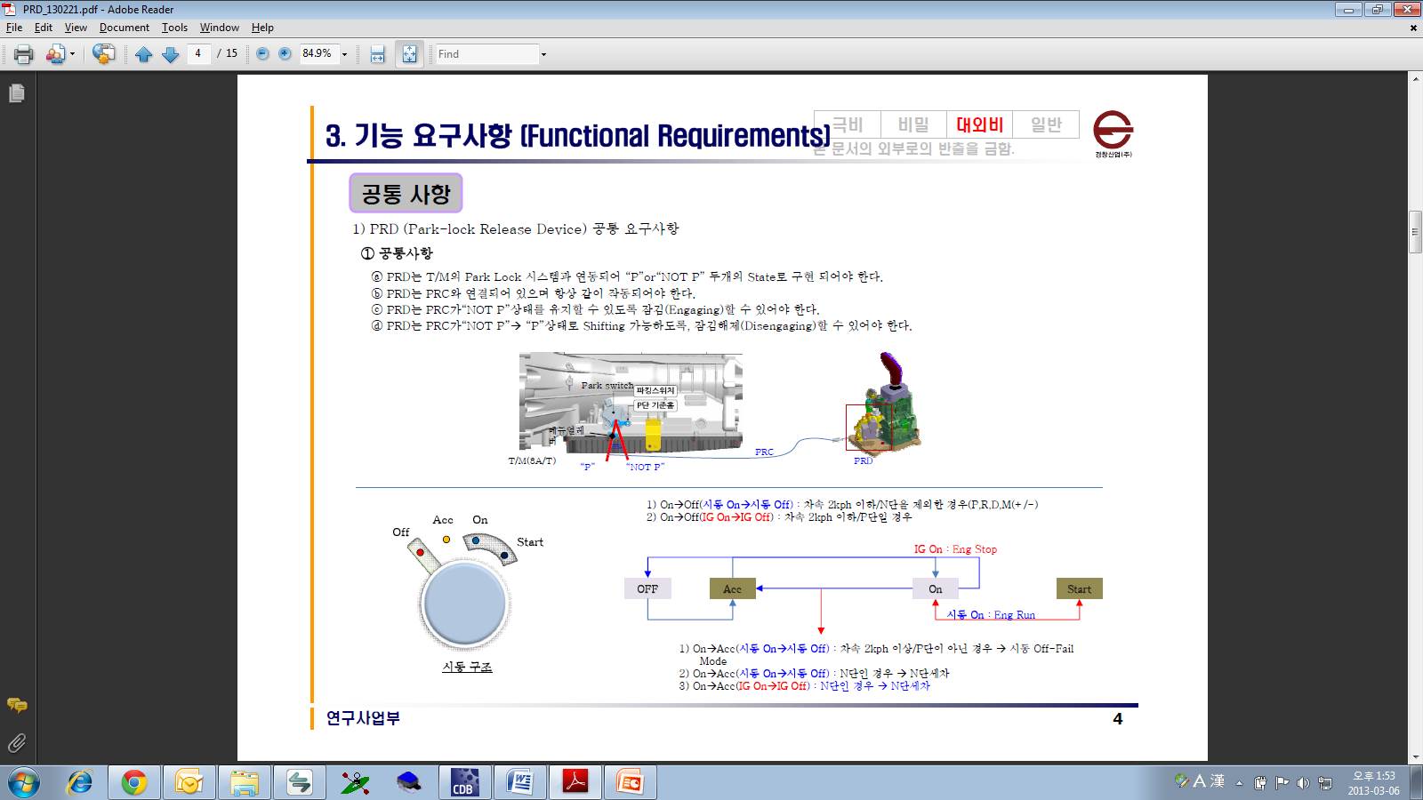
Figure 9: T/M Switch connect diagram

PRA Position Determination
PRA position is decided by both PRA sensor and T/M switch. If they have the same position, SBW will consider PRA position as this position. Otherwise, SBW will consider PRA position failure.

Error Detection

- SBW shall detect PRA error position.
For detail detect and release condition, please see the DTC list.

PRA Motor control

PRA Motor control rate
While control the PRA motor to Not P position, the SBW should driver the motor from 10% duty cycle and add 10% every 10ms until 100% duty cycle.
While control the PRA motor to Not P position, the SBW should driver the motor 0% duty cycle and add 10% every 10ms until 70% duty cycle.

Error Detection
- SBW shall detect the output high/low side short.
- SBW shall detect over temperature and under voltage.
For detail detect and release condition, please see the DTC list.

PRA Logic

IG ON Mode
If PRA positon is not P and Gear changes to NOT N position, SBW shall operate PRA to P Position.
If P Switch pressed ON while IGN ON and vehicle stop, SBW shall operate PRA to P position.

TCU OFF
While signal “G_SEL_DISP” is time out, SBW shall in TCU OFF mode.
- When last gear is D, SBW shall operate PRA to “Not P position”
- When last gear is P,R or N SBW shall keep PRA in “P position”
- After PRA is operated from “Not P” Position to “P” position, SBW should not operate PRA again while keep in TCU OFF condition unless IGN OFF to ON again.
- When P switch is pressed when vehicle is stopped, SBW shall operate PRA to “P position”.

TCU Request
- SBW received CF_Tcu_PrelReq = 0x1(0->1 edge) from TCU, SBW shall operate PRA to “Not P position” while P switch is not pressed.
- SBW receives CF_Tcu_PrelReq = 0x0 (1->0 edge) from TCU SBW shall operate PRA to “P position”.
- During the activating to “Not P position” by receiving CF_Tcu_PrelReq = 0x1 from TCU, if receiving the CF_Tcu_PrelReq = 0x0 from TCU, then SBW shall operate PRA to “P position” immediately.
- Otherwise SBW shall ignore TCU request, without any PRA operation.

Recovery TCU OFF at Vehicle Driving
- When last gear is D, SBW shall operate PRA for “Not P position” while TCU recovery happened.

Recovery TCU OFF at Vehicle Stop
- When last gear is D, SBW shall operate PRA to “P position” while TCU recovery happened.

IG OFF Mode
While entering IG OFF Mode, SBW shall detect the vehicle driving or stop status at the first time and operate different behaviour like below.

Vehicle Driving
- When the last gear is D, R or P SBW shall keep PRA to “Not P Position”.
- After the vehicle speed is less than 1km/h, then SBW shall keep PRA for “P Position”.

Vehicle Stop
- When the last gear is D, R or P SBW shall keep PRA to “P Position”.

Gear N IG OFF Mode
- SBW shall initially keep PRA to “Not P position” unless below condition happened:
a. If the door is open (DRV or AST), SBW shall keep PRA to “P position”
- While timeout, SBW shall operate PRA to “P position”

N Park Mode
- If valid P-Release switch press happened, SBW shall operate PRA to “Not P” position.
- If valid P switch press happened, SBW shall operate PRA to “P” position.
- In this mode, SBW shall operate PRA between “Not P” position and “P” position before the sleep mode
- Even if timeout is expired during P-Position ↔ Not-P Position operation, SBW should complete PRA operation to P-Position or Not P-Position, then SBW goes into sleep mode.

Manual Release Function
- The manual release function is only allowed in below condition:
N Park Mode (PRA Not P Position) -> Pressed P switch (PRA P Position)
After that, manual release is allowed in current IGN Off cycle.
- When IG ON, if driver do manual release, Waits 4 seconds, SBW shall operate PRA to P position.
- In other Manual Release is not allowed condition, if driver do manual release, Waits 4 seconds, SBW shall operate PRA to P position.
- If Driver Door open in Standby mode, SBW shall not allowed the manual release. If driver do the manual release, SBW shall waits 4 seconds, then operate PRA to P position.

TCU Eol Complete

General
- When receiving the “TCU EOL Complete” (CF_Tcu_GSel_BlinkReq signal) from TCU, SBW shall operate PRA.

CAN Signal
- SBW shall receive the “ CF_Tcu_GSel_BlinkReq” from TCU
- The value table
0x0: No blink/
0x1: Request lamp blinking

PRA P position
- If the “TCU Eol Complete” value is 1 to 0 edge, SBW shall operate PRA to P position.
- If the “TCU Eol Complete” value is 0 and Pressed P switch, SBW shall operate PRA to P position.

PRA Not P position
- If “TCU Eol Complete” value is 1, and IGN ON&& P switch==OFF && Unlock switch 5times within 2sec.

Limp-Home function

Judgment LimpHome Mode
- LimpHome Mode OFF: The battery voltage is less than 8V, more than 8.5V.
- LimpHome Mode ON: The battery voltage is between 8V and 8.5V.

Operation
- IGN OFF and Determine a low voltage range (8v – 8.5v) and execute an operation command of “P” or “Not P” to PRA depending on the input of valid P switch press and valid P-Release switch press.
- Operation of P -> Not P and Not P -> P shall be available once (Parking in “N” is available once).
- IGN ON and PRA is not P position within low voltage range (8v-8.5v), then SBW shall operate PRA to P position.
- The limp home voltage should be debouced as 500ms.
* The value here are all typical value for software logic, do not consider tolerance here.

PRA Disable Voltage

- SBW shall stop working PRA when the voltage is less than 8V, and recover from
undervoltage at 8.5V.
- When detecting the undervoltage, SBW shall disable the actuator output for protecting PRA.
- In the undervoltage, SBW shall not operate related PRA function. Otherwise SBW
- shall operate normal.
* The value here are all typical value for software logic, do not consider tolerance here.

System Mode Control

General

State Diagram
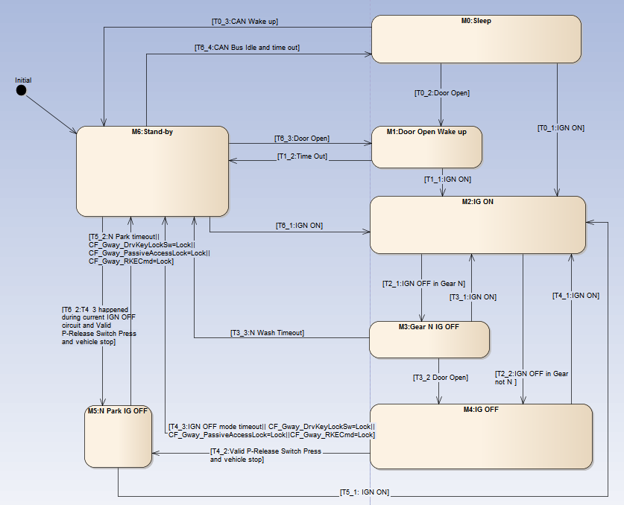
Figure 11: System state diagram

Mode Definition
- M0: Sleep
- M1: Door Open Wake up
- M2: IG ON
- M3: Gear N IG OFF
- M4: IG OFF
- M5: N Park IG OFF
- M6: Stand-by

Transition Definition
Each transition is named as Tx_y.
The x means the mode where the transition from.
The y means the priority of the transitions in same mode. The smaller number has higher priority.

- T0_1:IGN ON
- T0_2: Driver Door or Assist Door opened
- T0_3: CAN wake up
- T1_1: IGN ON
- T1_2: Mode Time out
- T2_1: IGN OFF in Gear N
- T2_2: IGN OFF in Gear not N
- T3_1: IGN ON
- T3_2: Driver Door or Assist Door opened
- T3_3: N Wash Timeout
- T4_1: IGN ON
- T4_2: Valid P-Release Switch Press and vehicle stop
- T4_3: IGN OFF mode timeout or vehicle lock
- T5_1: IGN ON
- T5_2: N Park mode timeout or vehicle lock
- T6_1: IGN ON
- T6_2: T4_3 happened during current IGN OFF circuit and Valid P-Release Switch Press and N Park IG OFF mode has not been entered in current IG OFF and vehicle stop
- T6_3: Driver Door or Assist Door opened
- T6_4: CAN Bus Idle and time out

Sleep Mode (M0)
SBW shall cut the MCU power to save the current consume in Sleep Mode.
The wake up source shall be:
a. IGN ON in H/W
b. Door Open in H/W
c. CAN wake up (partial network only for Driver Door and Assist Door Open)

Door Open Wake up Mode (M1)
A timer should be set in this mode. After timeout, SBW shall implement the T1_2 transition.
The mode timer should be set to 30s as initial value. If detected Door status from all off to open (only driver and assist door), the timer should be reset to 30s.

IG ON mode (M2)
While IGN ON, SBW shall always stay in this mode.

Gear N IG OFF Mode (M3)
A timer should be set in this mode. After timeout, SBW shall implement the T3_2 transition.
The timer should be set to 29min58sec. And the timer shall be started while detected vehicle stop.

IG OFF Mode (M4)
A timer should be set in this mode. After timeout, SBW shall implement the T4_3 transition.
The timer should be set to 30s. If detected Door status from all off to open (only driver and assist door), the timer should be reset to 30s.
If one of below conditions happens, the timer should be set to timeout:
- CF_Gway_PassiveAccessLock: 0x1: Lock
- CF_Gway_RKECmd: 0x1: Lock
- CF_Gway_DrvKeyLockSw: 0x1: lock

N Park IG OFF Mode (M5)
A timer should be set in this mode. After timeout, SBW shall implement the T5_1 transition. If PRA actuator is still working while timeout, SBW shall wait for the PRA actuator finish, then implement the T5_1 transition.
The timer should be set to 20s. If detected Door status from all off to open (only driver and assist door), the timer should be reset to 20s.
If one of below conditions happens, the timer should be set to timeout:
- CF_Gway_PassiveAccessLock: 0x1: Lock
- CF_Gway_RKECmd: 0x1: Lock
- CF_Gway_DrvKeyLockSw: 0x1: lock

Stand-by Mode (M6)
SBW should go to M5: N Park IG OFF mode following T6_2 while below conditions all meet:
a. In current IGN OFF circuit SBW directly transit the mode from M4: IG OFF directly to M6: Stand-by. (T4_3 happened)
b. Valid P-Release Switch ON
c. Vehicle stop
SBW should go to M0 after bus idle and 3 minutes timeout since IGN OFF.

Power Management

Over/Under Voltage
- If detecting the over/under voltage, SBW shall turn off all indication and disable functional communication.
- SBW shall detect under voltage when the voltage is less than 6.2V. And recover from under voltage at 7.1V. The fault detection time shall be more than 2000ms. But the DTC will be set while under 8V and cleared while over 8.5V.
- SBW shall detect over voltage when the voltage is more than 17.8V. And recover from over voltage at 16.9V. The fault detection time shall more than 1000ms. The DTC will be set while over 17V and cleared while under 16.5V.
* The value here are all typical value, do not consider tolerance here.

Variant Management

General

Option name | Signal | Description | DOM | EXP
Option P Release | b_P_ReleaseOption | Vehicle is equipped with P Release switch | On | OFF
Table 10: Variant Management table

The Variants parameter shall be stored in the NvRAM.
Refer to variants list.

The export variant will be covered by mechanical cover on P_Release switch, but the function of the P_Release switch shall be remained.

The export variant will disable the Level 4, Level 5 and Level 6 warnings in CAN Tx message LVR1.

Nr
Nd
R
D
“Nr”/”Nd”: Stable
“R”/”D”: Unstable

Adding CAN Signal

Calibrations

Auto N Mode Function Input/Output List

UDS Diagnosis
Generally SBW shall follow ES95486-00.

DTC list

Power

Park Release Actuator Assy.

Sensor

CAN

Switch (Park / Unlock / Park Release/TM )

In detail information, see the DTC List document
DTC Number | Description
C110117 | Battery Voltage High
C110216 | Battery Voltage Low
C242271 | Override Motor Fault
C242319 | Override Gear Fault
C138201 | Lever Hall Sensor Fault
C153364 | Shift Lever Error, P-Release Switch Fault
C153364 | Park Switch Fault
C153364 | Safety Switch Fault, Unlock Switch Fault
C224201 | PRA Hall Sensor Fault
C224102 | PRA Range Fault
C153794 | TM Switch Fault
C160404 | EEPROM Fault
C161688 | CAN Bus Off
C161287 | CAN VS_TCU Timeout Fault
C161287 | CAN G_SEL_DISP Timeout Fault
C161287 | CAN CF_Tcu_PRelReq Timeout Fault
C164686 | CAN VS_TCU Invalid Signal Fault
C164686 | CAN G_SEL_DISP Invalid Signal Fault
Table 11: DTC list

References
No | HKMC Name | DOC No./ CBD Link | Remark
1 | LH SR | DOC01737533-0001 / LH_SR_LEVER_COMPLETE-E.C.U_ENG.pptx
2 | LH CAN DB | DOC01750500-0003 / LH_SBW_CANDB_20160719_ENG.xls
3 | ES95480-00 | DOC01739271-0000 / ES95480-00E_High Speed CAN Design Specification_Rev.16.pdf
4 | LH Spec list | DOC01739393-0006 / LH_SbW Lever_SpecList
5 | Variants list | DOC01760217-0001 / LH_SBW_Variant list.docx
6 | ES95486-00 | DOC01739273-0001 / ES95486-00E
7 | DTC and Waring List | DOC01777593-0002 / LH_SBW_WarningDTC_Condition.xlsx
Table 12: references list

